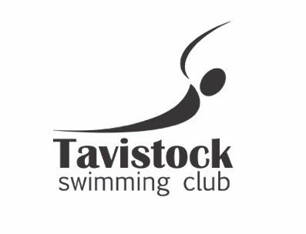
7th Dartmoor Sprint Meet Sunday 6th March 2022
Under ASA Laws & Technical Rules

License 4SW220209

At Parklands Leisure Centre, Okehampton, EX20 1EP

For new and developing swimmers aged 8 – 14 years
No Regional Qualifiers
Devon Qualifiers can enter (but not in the event they have a county time in)

8.30 Warm up for 9.15am Start
8/9, 11 & 13 years Age Groups

Warm up TBC
10, 12 and 14 years Age Groups

Age as on day of meet

EVENTS FOR ALL AGE GROUPS

50m Freestyle, Backstroke, Breaststroke, Butterfly
&
100m Individual Medley (All events heat declared winners)

Entry fee £5.50 per event

